[CSCI 5722] Computer Vision Homework #1

JeeeunKim ([jeeeun.kim@colorado.edu](mailto:jeeeun.kim@colorado.edu))

1. **Send an email to the group list introducing yourself.**

Done.

1. **What do the columns of a 3D rotation matrix represent?**

It indicates the coordinate of the rotated space, so how to get original points from the rotated(new) points

1. **What is the angle between the vectors defined by the columns of a rotation matrix?**

The angle between the vectors are theta(θ)

Each angles mean how much the vehicle (robot, camera, etc) moves from the original points to the other. The p means the angle how much the camera rolled, q means the angle how much the camera pitched, and r means the angle how much the camera yawed.

1. **What is the determinant of a rotation matrix?**
$$\cos{θ^{2}}+ \sin{θ^{2}}=1$$

2. **Write the function R = pqr2R(pqr) that takes 3*1 set of Euler “roll-pitch-yaw” angles, pqr, and produces a 3*3 rotation matrix R using the roll-pitch-yaw fixed-frame convention for** **rotation matrices**

function R = pqr2R(pqr)

p = pqr(1); q = pqr(2); r = pqr(3);

R(1,1) = cos(p)*cos(r)-sin(p)*sin(q)*sin(r);

R(1,2) = cos(r)*sin(p)+cos(p)*sin(q)*sin(r);

R(1,3) = -cos(q)*sin(r);

R(2,1) = -cos(q)*sin(p);

R(2,2) = cos(p)*cos(q);

R(2,3) = sin(q);

R(3,1) = cos(p)*sin(r)+cos(r)*sin(p)*sin(q);

R(3,2) = sin(p)*sin(r)-cos(p)*cos(r)*sin(q);

R(3,3) = cos(q)*cos(r);

End

1. **Write a function pqr = R2pqr(R) that takes a 3*3 rotation matrix, R, and outputs a 3*1 set, pqr, of Euler angles. Test that your function is correct by checking: pqr – R2pqr(pqr2R(pqr)) == 0**

function pqr = R2pqr(R)

if(R(1,3) > 0)

q = pi - asin(R(2,3));

else

q = asin(R(2,3));

end

pqr(2,1) = q;

pqr(1,1) = acos(R(2,2)/cos(q));

pqr(3,1) = acos(R(3,3)/cos(q));

End

1. **Is the function y = R2pqr(pqr2R(x)) bijective?**

No, it doesn’t take angles out of 0 < angle < Pi, because the sin and cos are not bijective at such angles. If the angle is out of range, the elements of each input set doesn’t match one by one vice versa.

1. **What is a covariance matrix?**

A matrix whose element in the i, j position is the covariance between ith and jth element of a random vector.

1. **What does a large covariance matrix indicate?**

Large number in the covariance matrix indicates the points of observation values are scattered a lot, less associated between each points as a set.

1. **What, geometrically, does the determinant measure?**

In 3D space, the determinant draws a points when given observed values, forming a polygon in the 3d space. The determinant defined by those points shows the volume of this polygon.

1. **Write the multivariate Gaussian distribution** 
 $$f_{x}\left(x_{1}, …, x_{k}\right)= \frac{1}{\sqrt{{(2π)}^{k}}\left|Σ\right|}exp⁡(-\frac{1}{2}{(X- μ)}^{T}Σ^{-1}(X- μ))$$

  1. **What is the meaning of the determinant in this expression?**

How randomly observed points over large enough times are distributed in the 3D space. How far each points is scattered on the plane.

* 1. **Does the determinant depend on the mean?**

No, regardless of the mean, how scattered the points are not changing, as it indicates the area (or volume) of scattered points.

1. **Derive the T2Cart and Cart2T functions for 3D poses.**

function Xvc = T2Cart(T)

R = T(1:3, 1:3);

xyz = T(1:3,4);

pqr = R2pqr(R);

Xvc = [xyz,pqr];

end

function T = Cart2T(Xvc)

t = Xvc(1:3);

pqr = Xvc(4:6);

R = pqr2R(pqr)

T = [R t;0 0 0 1];

end

1. **Derive the $⨁$**  **and $⊖$**  **operators**

$$x_{wc}= T2Cart(Cart2T(Cart2T\left(x_{wv}\right)Cart2T\left(x_{vc}\right))$$

$$x_{ba}=T2Cart(Cart2T({{(x}_{ab})}^{-1})$$

**(a) what do they do?**

$$x_{wc}= x_{wv} ⨁ x_{vc}$$

Given the pose of the vehicle V, the pose of the camera C, one move of transposing world to the camera is computed by compounding two moves, transposing from world to vehicle, and vehicle to the camera.

$$x_{ba}= ⊖ x_{ab}$$

Transposing from one point (b) to the other (a) is inversing transposing from (a) to (b)

1. **Write a matlab function h = plot_cf( pose ) that takes a 6x1 pose (or a 4x4 matrix) and draws a red-green-blue coordinate frame basis. You should return a vector of graphics handles for the plotted objects (so that delete(h) in matlab will remove the objects from the figure.)**

**Extra credit: draw cylinders with cones for each axis:**

function h = plot_cf(pose)

pqr = pose(1:3);

R = pqr2R(pqr);

origin = [0,0,0]';

x = R*[1,0,0]';

y = R*[0,0,-1]';

z = R*[0,1,0]';

cx = origin + x; % new vector c = origin ~ xyz

cy = origin + y;

cz = origin + z;

starts = [pose(1) pose(2) pose(3);

pose(1) pose(2) pose(3);

pose(1) pose(2) pose(3)];

ends = [cx cy cz];

quiver3(starts(:,1), starts(:,2), starts(:,3), ends(:,1), ends(:,2), ends(:,3))

%quiver3(x,y,z,u,v,w) = direction (u,v,w), points determined by (x,y,z)

axis equal

end

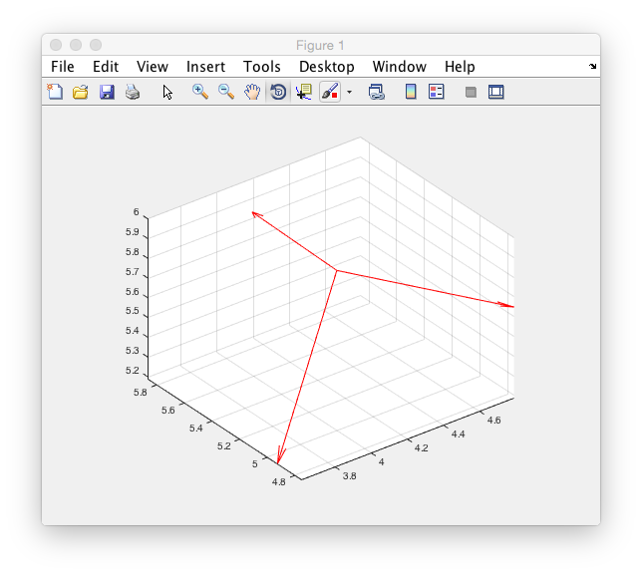

When pose were given as:

Pose = [4 5 6 0 0 0]’

Note: it does not return the handle as a vector of graphics.